資工三 黃偉祥 111010550

作業一 : userClassifier 的應用

Step 1 : Install userClassifier

- Choose “Tools” -> “Package manager”

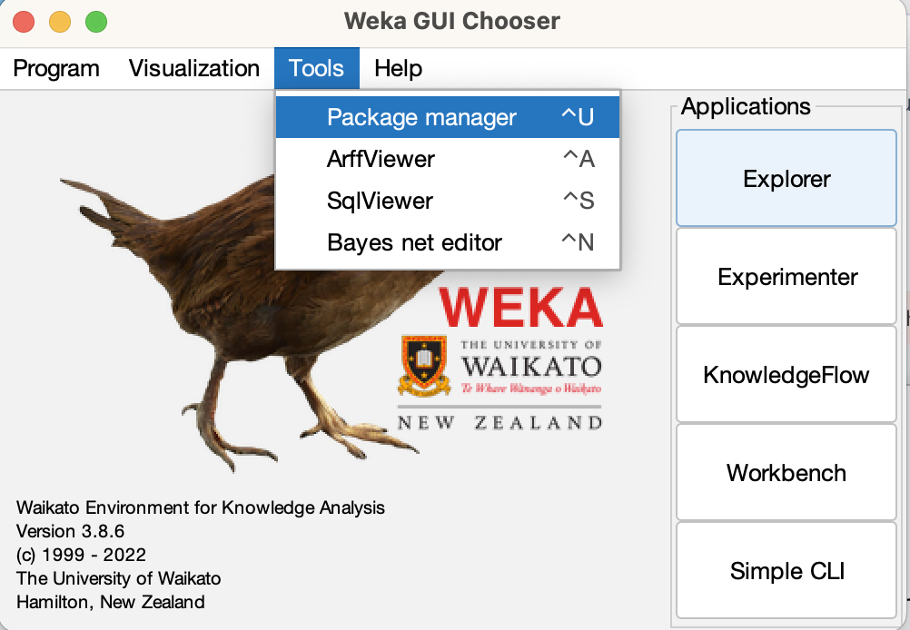

- Enter “userClassifier” , and click install

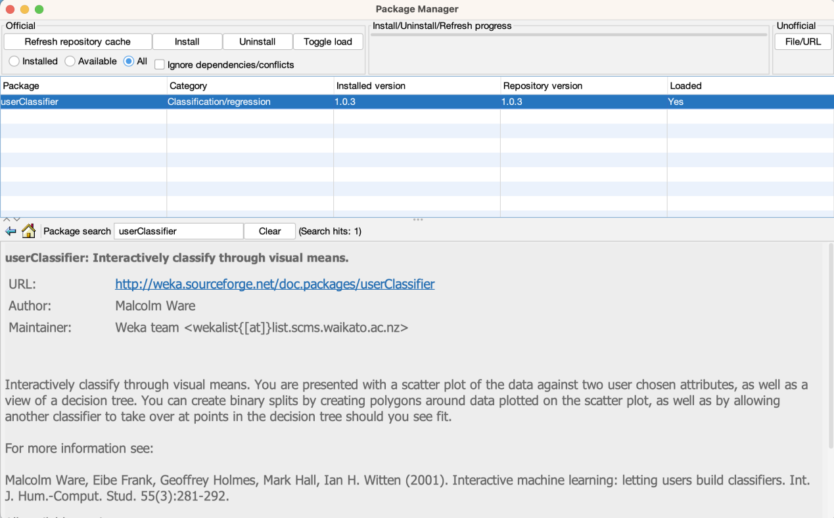

Step 2 : Choose target file and select “userClassifier”

- Select UserClassifier

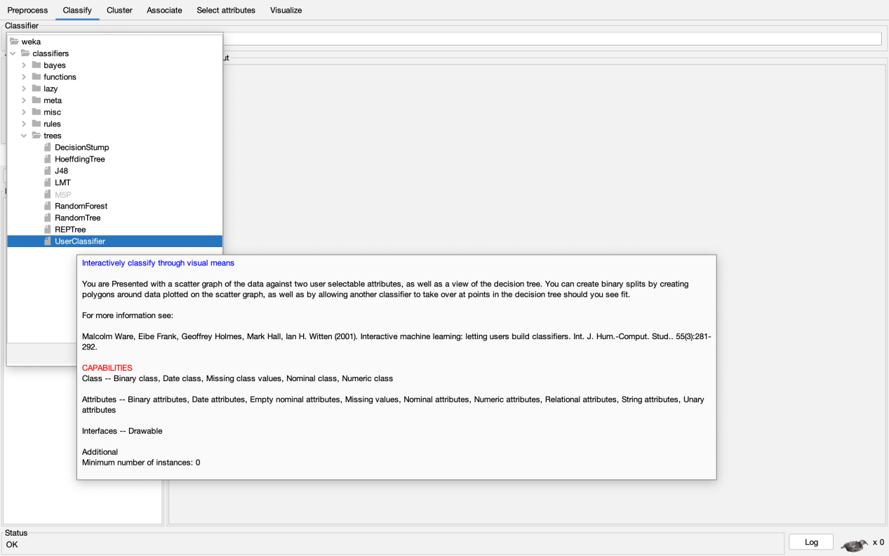

- segment-challenge.arff as example

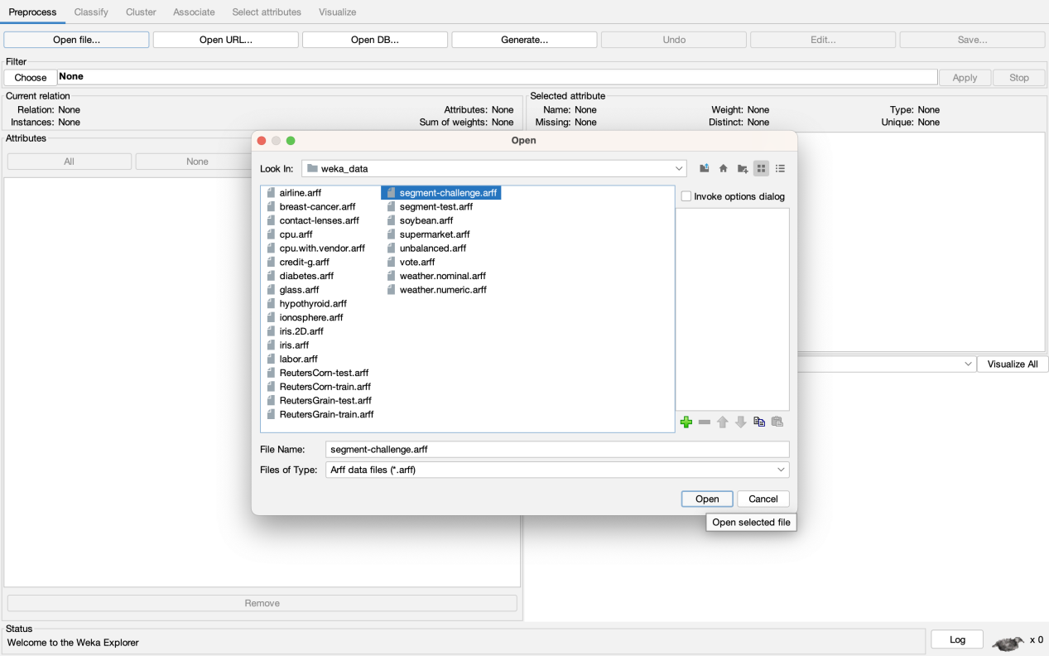

- Use “Supplied test set” and choose “segment-test.arff”

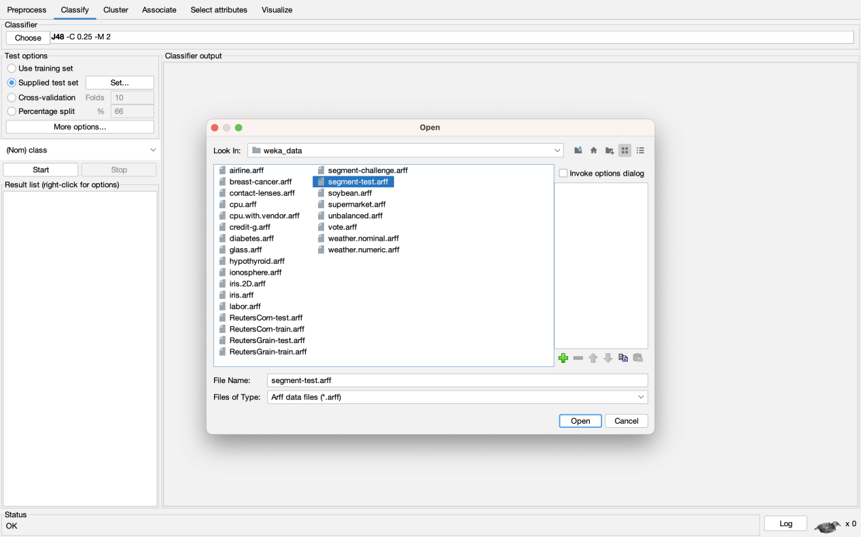

Step 3 : Build your own classifier

- Click “Start” and choose “Data Visualizer”

- Follow below step to circle the data with “Polygon” Instance

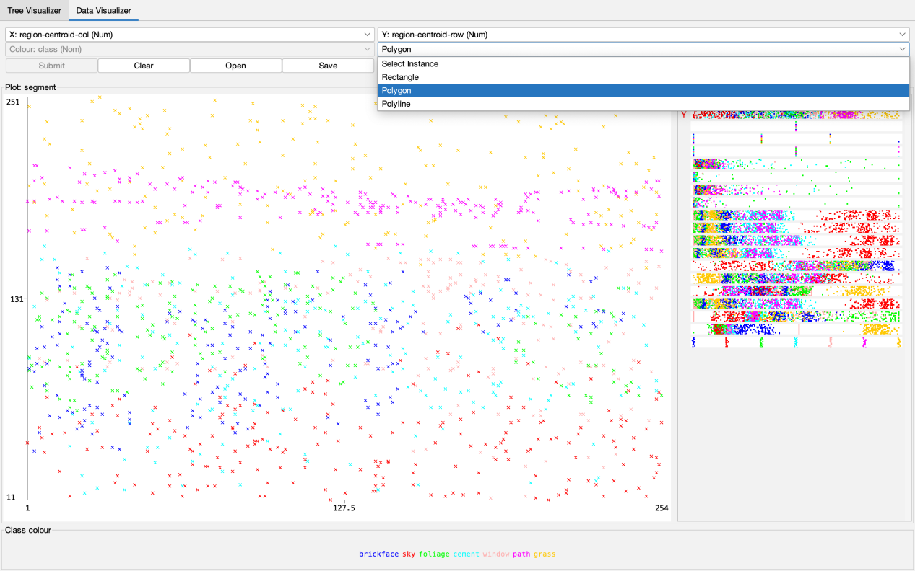

- Polygon 1

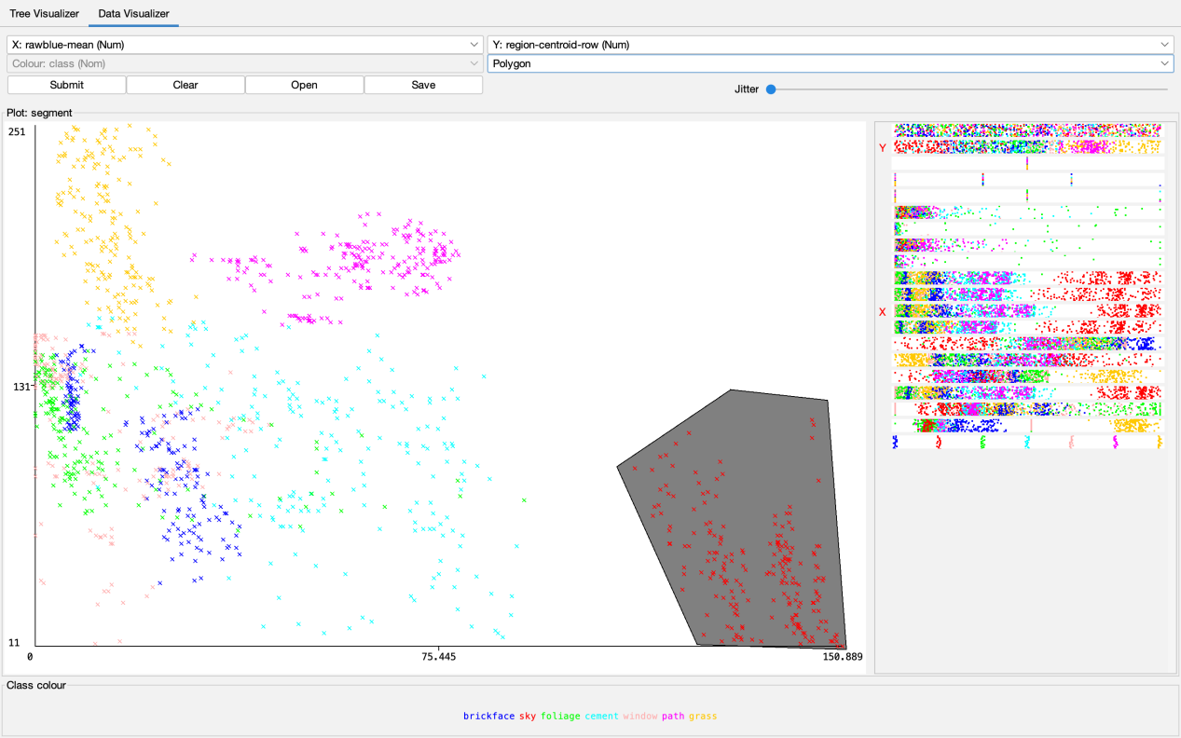

- Polygon 2

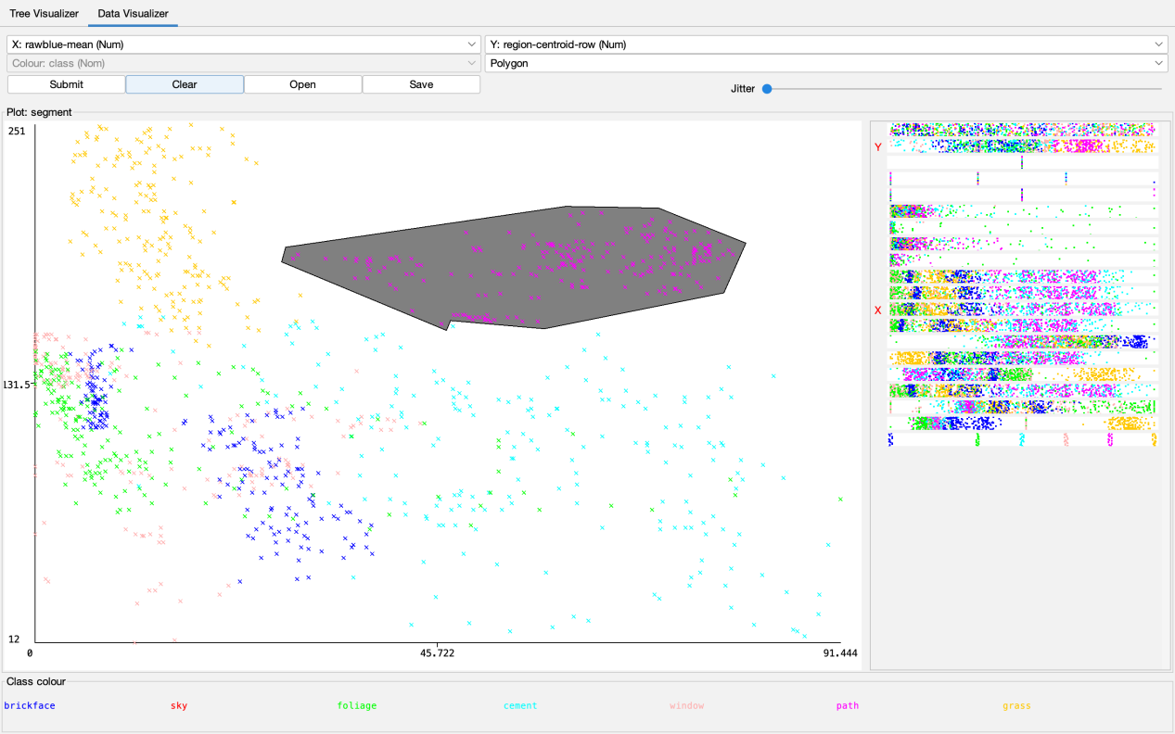

- Polygon 3

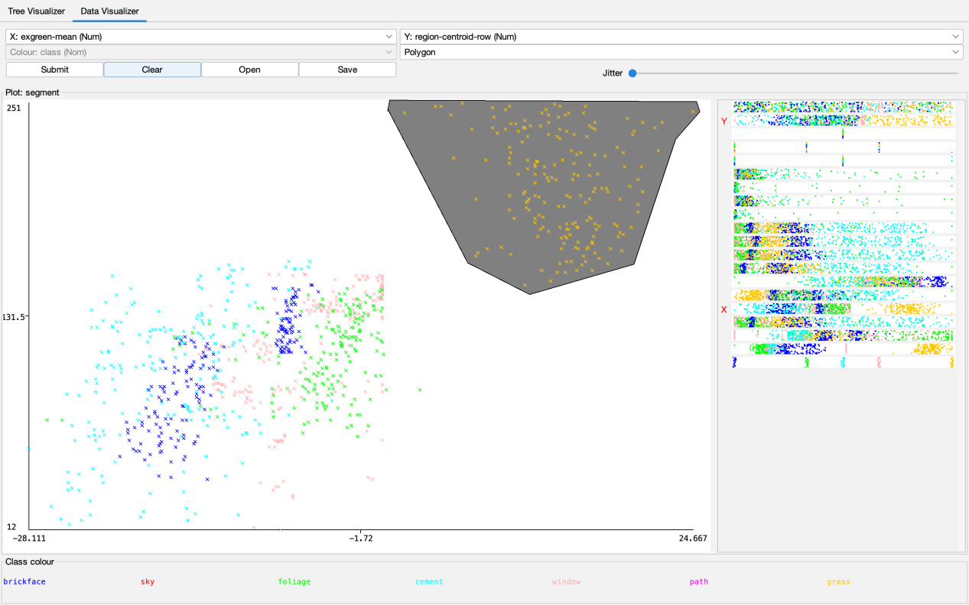

- Polygon 4

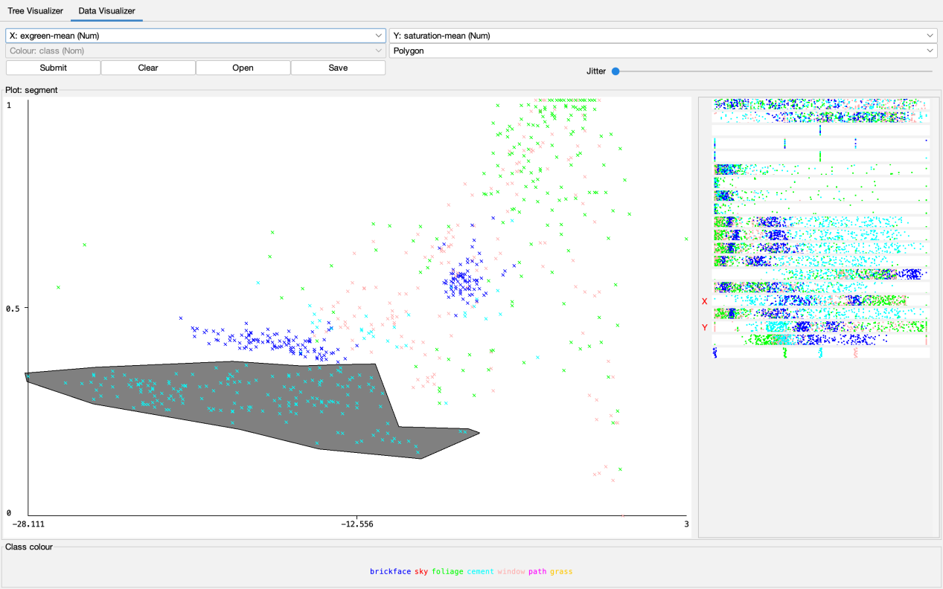

- Polygon 5

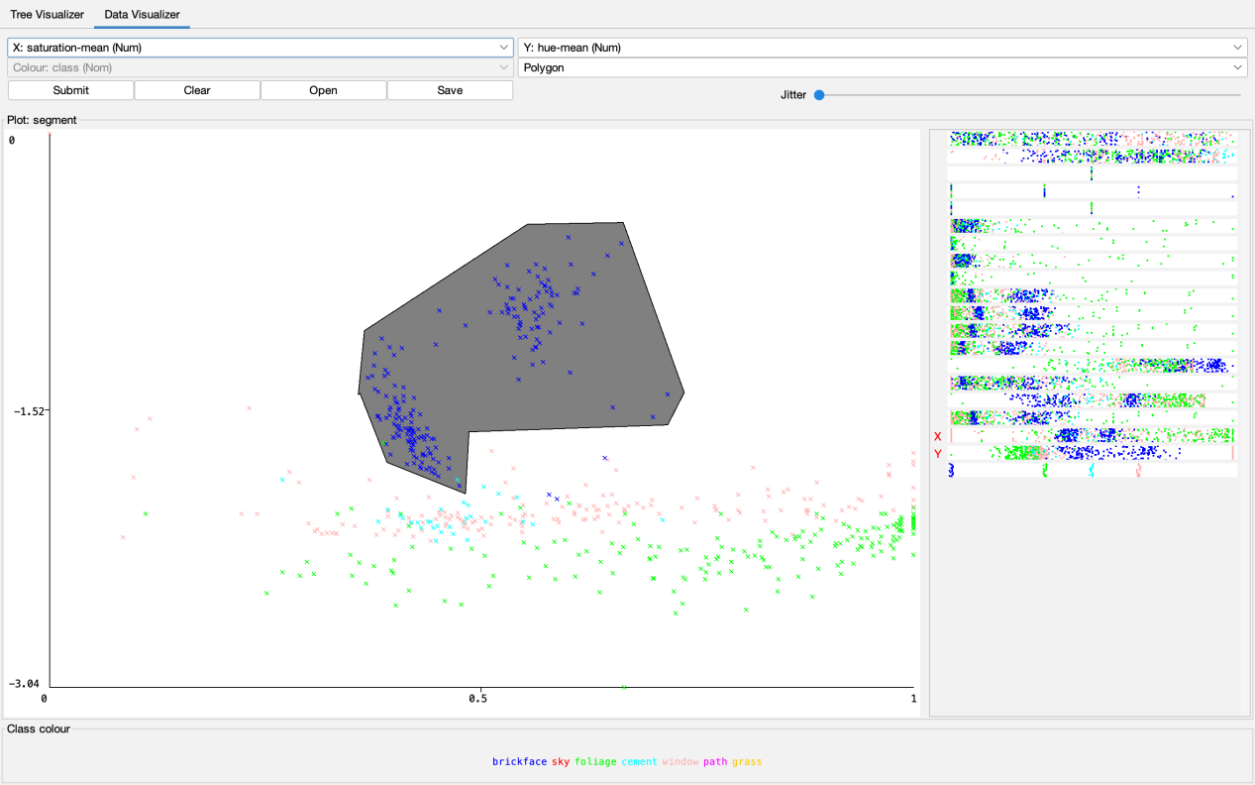

- Polygon 6

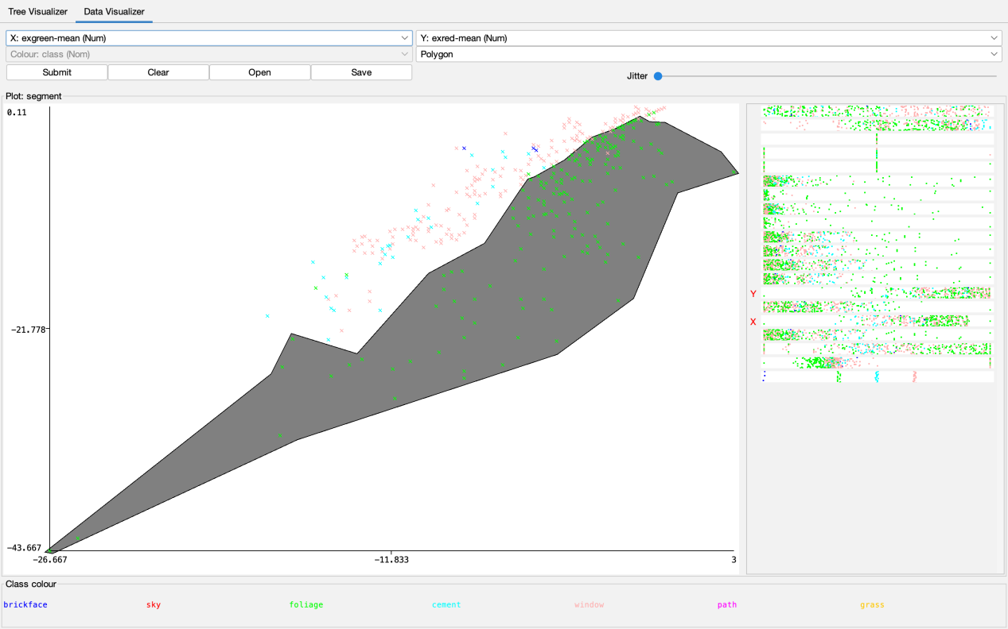

- Polygon 7

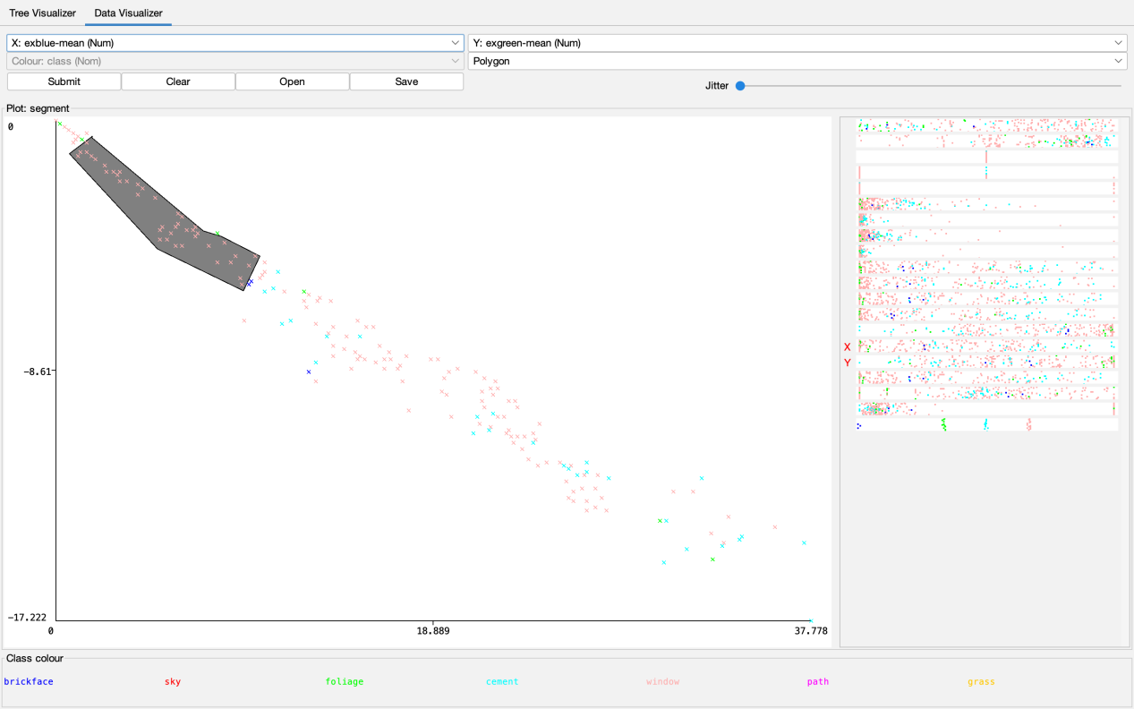

- Polygon 8

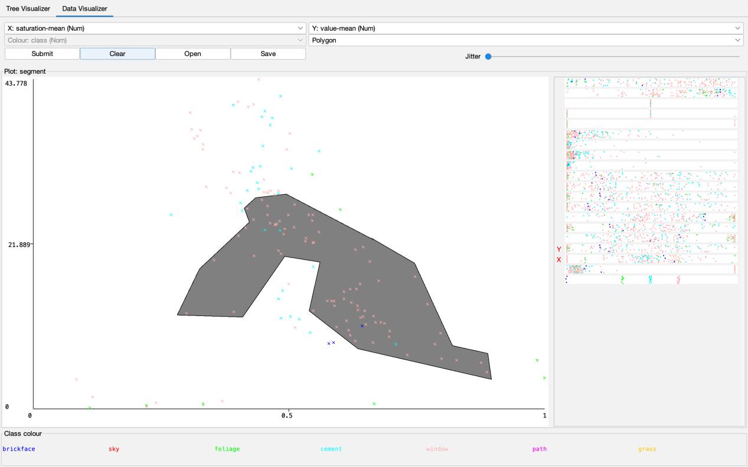

- Polygon 9

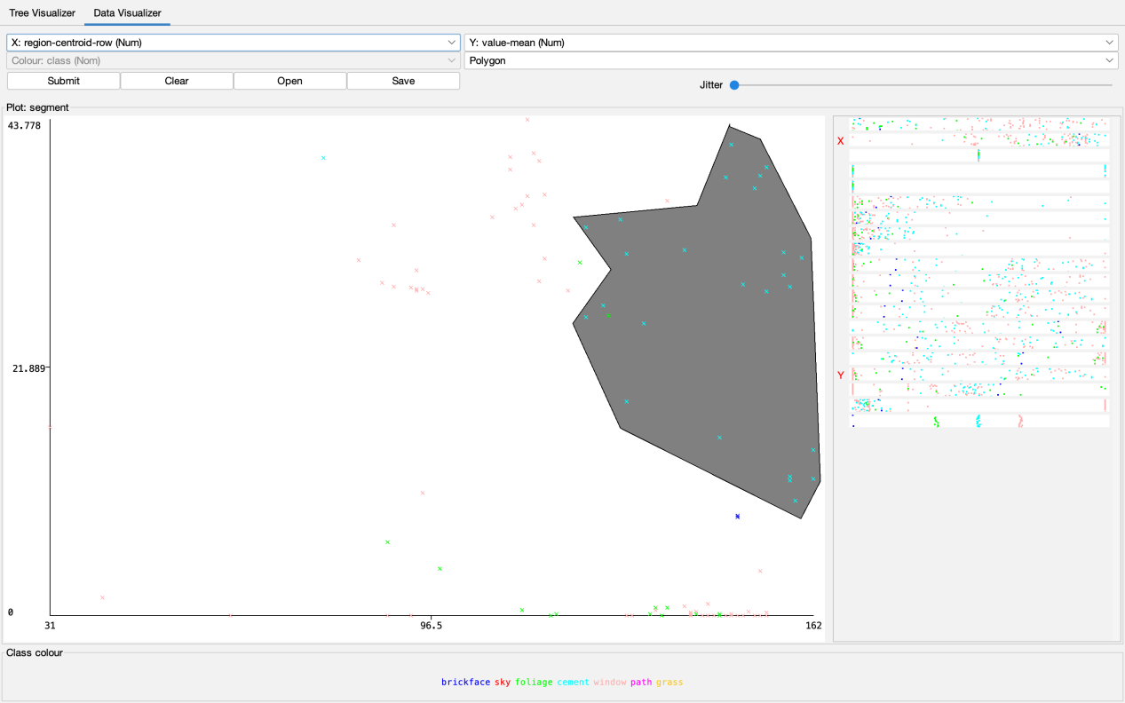

- Polygon 10

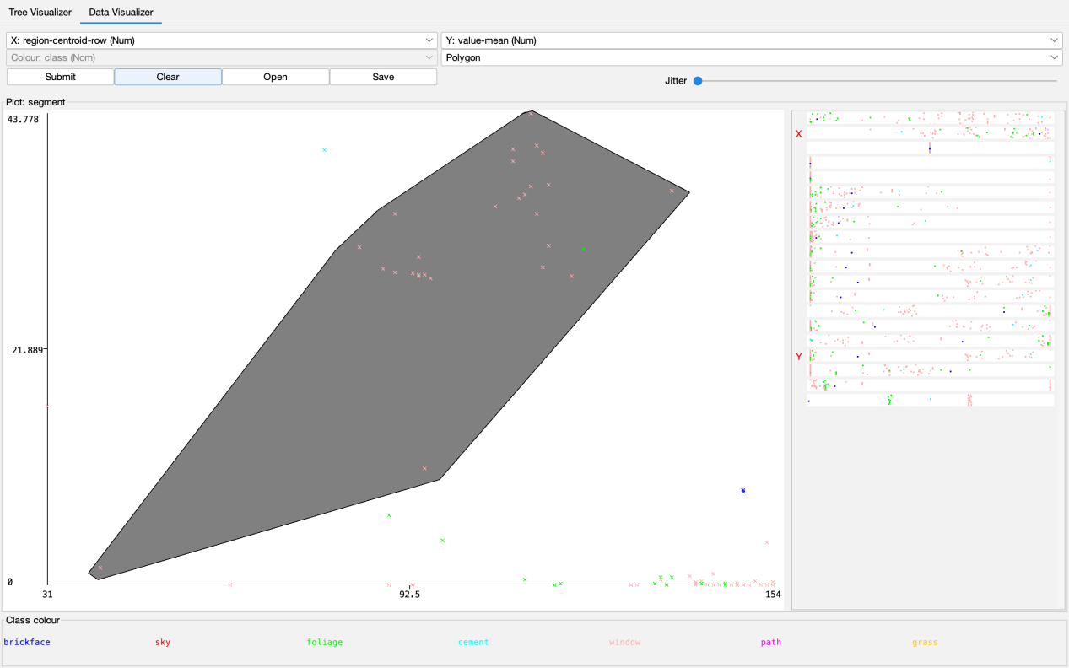

- Polygon 11

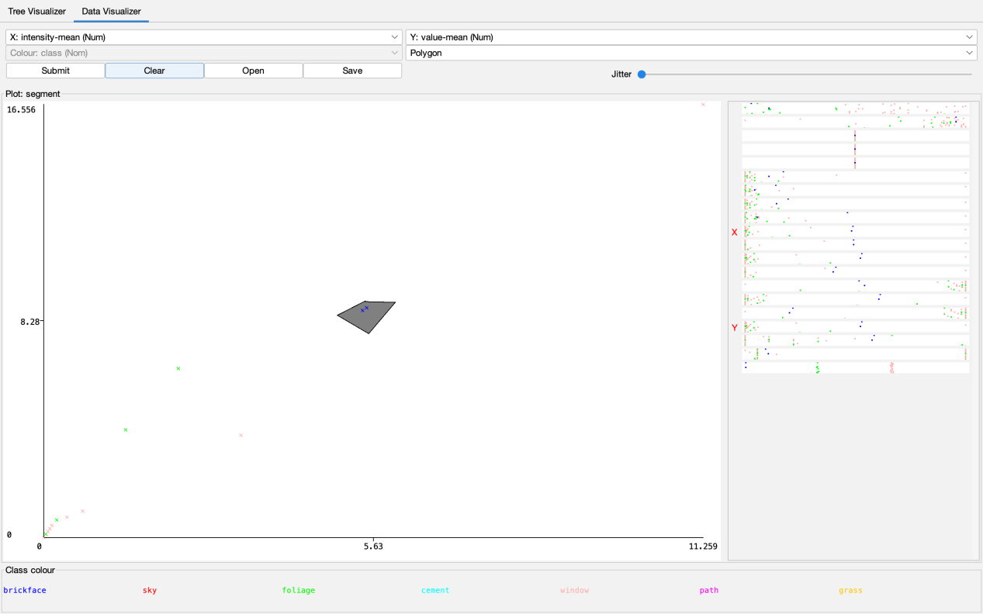

- Polygon 12

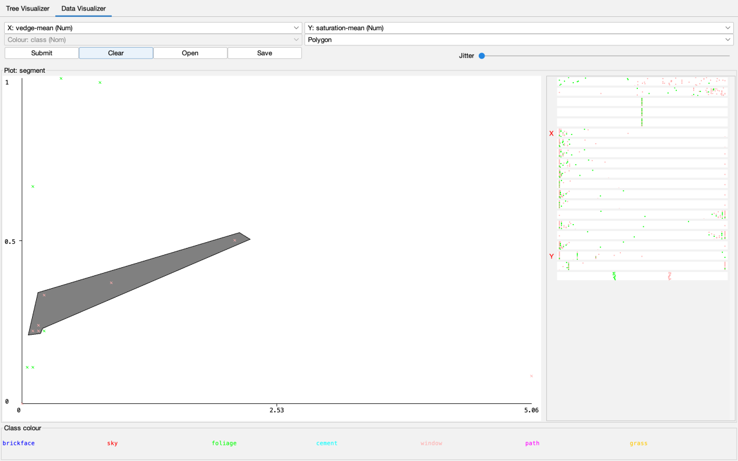

- Polygon 13

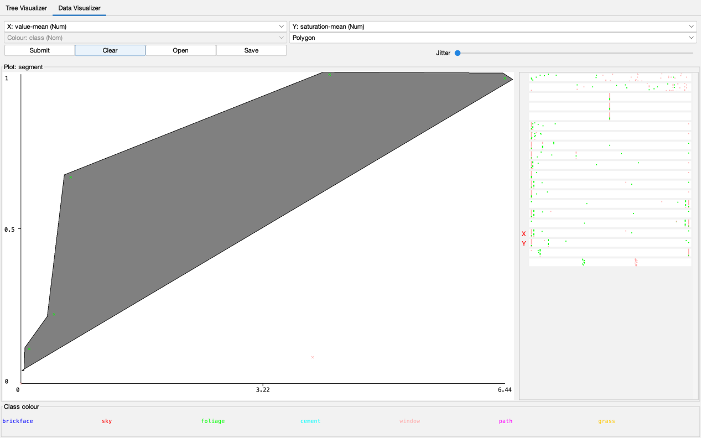

- Polygon 14

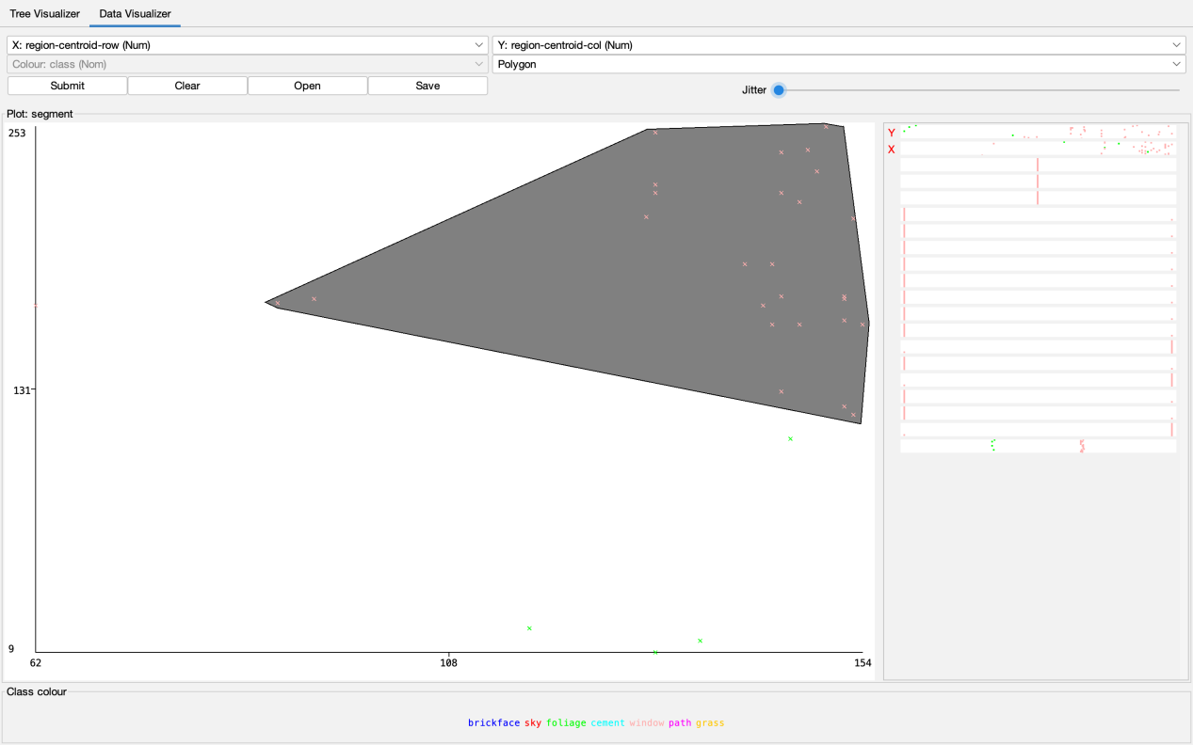

- Polygon 15

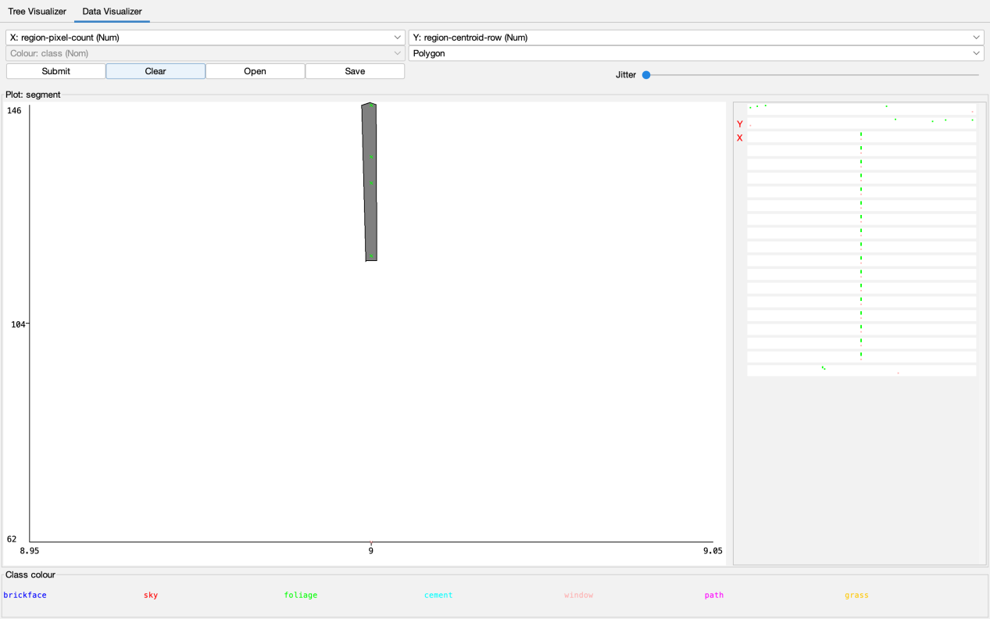

Step 4 : right click and accept the tree

- Now we got 94.5679% accuracy

